**Chapter 6**

**Vector Calculus**

**6.2 Line Integrals**

**Section Exercises**

39. *True or False*. Line integral  is equal to a definite integral if *C* is a smooth curve defined on  and if function *f* is continuous on some region that contains curve *C*.

Answer: True

41. *True or False*. 

Answer: False

43. *True or False*. If *C* is given by  then 

Answer: False

**For the following exercises, use a computer algebra system (CAS) to evaluate the line integrals over the indicated path.**

45. **[T]** 

 when 

Answer: 

47. **[T]**Evaluate  where *C* is the right half of circle  and is traversed in the clockwise direction.

Answer: 

**For the following exercises, find the work done.**

49. Find the work done by vector field  on a particle moving along a line segment that goes from  to 

Answer: 

51. Find the work done by force field  on a particle as it moves along the helix  from point  to point 

Answer: 

53. Find the work done by force  in moving an object along curve  where 

Answer: 

**For the following exercises, evaluate the line integrals.**

55. Evaluate , where, and *C* is the part of the graph of from  to 

Answer: 

57. Evaluate  over the line segment from  to 

Answer: 

59. **[T]** Use a computer algebra system to evaluate the line integral  where *C* is the arc of the parabola  from (–5, –3) to (0, 2).

Answer: 

61. **[T]** Use a CAS to evaluate line integral  over path *C* given by  where 

Answer: 

63. **[T]** Use a CAS to evaluate , where *C*is 

Answer: 

**In the following exercises, find the work done by force field F on an object moving along the indicated path.**

65. 

Answer: 

67. 



Answer: 

69. Compute the work done by force  along path , where .

Answer: 

71. Force  acts on a particle that travels from the origin to point (1, 2, 3). Calculate the work done if the particle travels:

1. along the path  along straight-line segments joining each pair of endpoints;
2. along the straight line joining the initial and final points.
3. Is the work the same along the two paths?

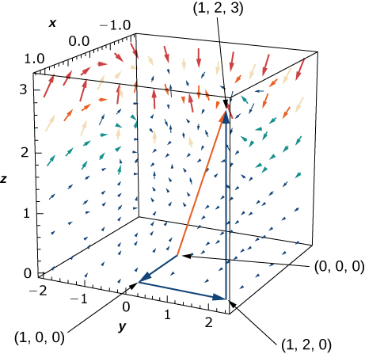

Answer: a.  b.  c. Yes

73. How much work is required to move an object in vector field  along the upper part of ellipse  from (2, 0) to 

Answer: 

75. Evaluate the line integral of scalar function  along parabolic path  connecting the origin to point (1, 1).

Answer: 

77. Find  along *C*:  from (0, 0) to (1, 3).

Answer: 

**For the following exercises, use a CAS to evaluate the given line integrals.**

79. **[T]** Evaluate line integral  where,  is the arc of curve  from  to 

Answer: 

81. **[T]** Evaluate line integral  where  is curve  from

(1, 0) toward 

Answer: 

83. **[T]** Evaluate , where  and

*C*: 

Answer: 

85. Find the line integral of  over path *C* defined by ,  from point (0, 0, 0) to point (2, 4, 8).

Answer: 

**For the following exercises, find the flux.**

87. Compute the flux of  across a line segment from (0, 0) to (1, 2).

Answer: 

89. Let  and let *C* be curve  Find the flux across *C*.

Answer: 

91. Let  Calculate flux **F** orientated counterclockwise across curve *C*: 

Answer: 

93. A spring is made of a thin wire twisted into the shape of a circular helix  Find the mass of two turns of the spring if the wire has constant mass density.

Answer: 

95. An object moves in force field  counterclockwise from point (2, 0) along elliptical path  to  and back to point (2, 0) along the *x*-axis. How much work is done by the force field on the object?

Answer: 

97. If an inverse force field **F** is given by  where *k* is a constant, find the work done by **F** as its point of application moves along the *x*-axis from 

Answer: 

This file is copyright 2016, Rice University. All Rights Reserved.